**Compass versus PeopleSafe System Documents and theSource Feedback**

Compass versus PeopleSafe System Documents

theSource Feedback

Related Documents

**Description:** Describes how Compass trained users should not be accessing PeopleSafe system documents and provides the proper way to provide feedback using theSource. Compass and PeopleSafe system documents are not expected to align.

|  |
| --- |
| Compass versus PeopleSafe System Documents |

As we near the end of migration to Compass for Commercial Care CCR’s, there will be less focus and time spent on non-critical PeopleSafe document updates.

Do not expect Compass and PeopleSafe system documents to align.



 Compass users should **not be referencing** PeopleSafe system documents after they have migrated to Compass.

Top of the Document

|  |
| --- |
| theSource Feedback |

**theSource Feedback:**

**It Needs Improvement:** Would you please focus on providing feedback for the **Compass** system documents instead of PeopleSafe system documents?

* If there is missing information in the Compass documents, would you please provide detailed feedback using theSource.

**Example:**

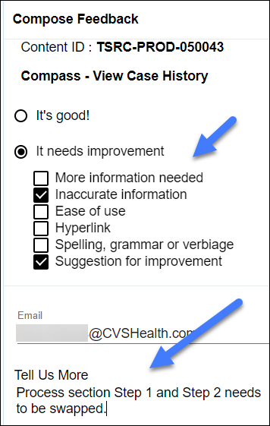

**It’s Good:** Please **do not use this option unless** you have a specific comment about a particular document. This slows down the process of working through all of the incoming responses.

**Example:** (Preferred Limited Usage)

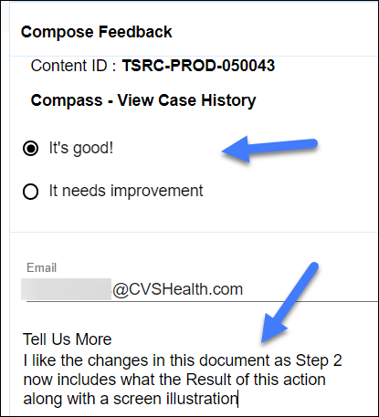

**Refer to** [Submitting Feedback in theSource Job Aid (020332)](https://thesource.cvshealth.com/nuxeo/thesource/#!/view?docid=e5c2ef71-408c-42f0-9686-bbf05b6f711c).

Top of the Document

|  |
| --- |
| Related Documents |

[Customer Care Abbreviations, Definitions and Terms Index (017428)](https://aetnao365-my.sharepoint.com/personal/david_davis_cvshealth_com/Documents/Downloads/CMS-2-017428)

Top of the Document

**ELECTRONIC DATA = OFFICIAL VERSION / PAPER COPY = INFORMATIONAL ONLY**